Name: Abhinay P
Domain: Data Analyst
Project: Twitter Analytics Dashboard-Power BI
Task 3: Build a chart to identify top 10 tweets by the sum of retweets and likes. Filter out tweets posted on weekends and show the user profile that posted each tweet and this graph should work only between 3 PM IST to 5 PM IST apart from that time we should not show this graph in dashboard itself and the tweet impression should be even number and tweet date should be odd number as well as tweet word count below 30.
Data preparation & calculated columns:
Several calculated columns were created within Power BI to support filtering and ranking logic. It includes:
- Tweet word count to identify tweets with less than 30 words
- Tweet date extracted from the date time
- Odd date indicator to include tweets posted on odd-numbered dates
- Weekend indicator to exclude tweets posted on Saturdays and Sundays
- Time window indicator to restrict the visualization to 3 PM- 5 PM IST
- Even impression indicator to include only tweets with even impression counts
- Total engagement to calculate the combined value of retweets and likes for ranking
Visualization Design:
A clustered bar chart was used to display the results, as it is well suited for ranking and comparing entities based on a single metric. Each bar represents an individual tweet, identified by its Tweet ID, and the bar length corresponds to the total engagement value.
The chart was supposed to display the top 10 tweets, ranked by total engagement, with the understanding that fewer than ten bars appeared because the dataset does not contain enough qualifying records.
Filters and constraints applied:
- Posted on a weekday
- Published within the 3 PM- 5 PM IST time window
- Have an even number of impressions
- Were posted on an odd-numbered date
- Contain fewer than 30 words
Result:
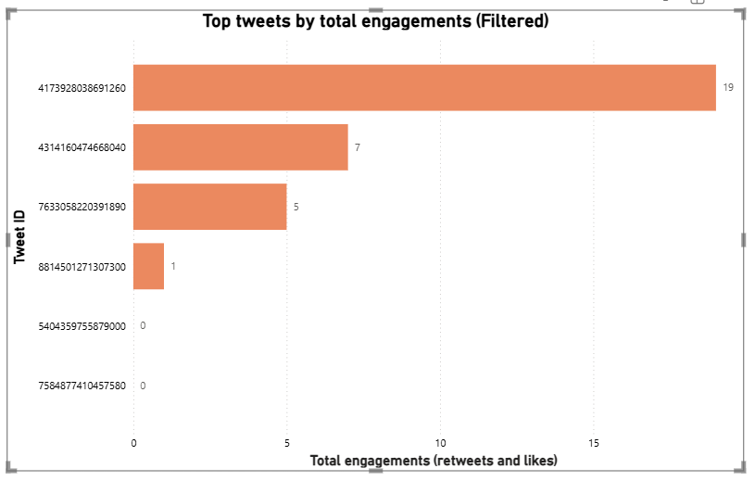
In this image we can see that the there are less than 10 observations which are satisfied after applying all the conditions and filters. The highest total engagements in the visual is noted to be 19 which are likes of the tweet and from the data it is shown that none of this bar has a retweet in the data which indicates that all these readings in the bar are totally likes of the tweets.
Conclusion:
This analysis demonstrates the effective use of calculated columns, visual-level filters, and ranking logic in power BI to produce a controlled and accurate visualization. The final chart correctly represents the top-performing tweets based on combined engagement. The outcome highlights both engagement trends and dataset limitations.

